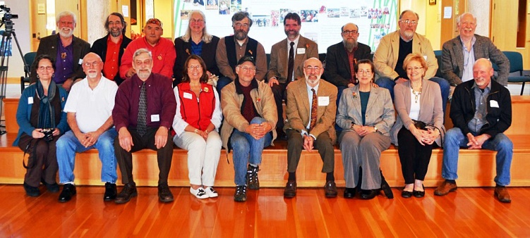
OZETTE/MAKAH Crew attending Dr. Richard Daugherty’s 92nd Birthday Tribute, Squaxin Island Tribe Museum, Shelton, WA March 31, 2014
Front row: Helen Carlson, Greig Arnold; Bob Weaver; Meri Parker; Greg Colfax; Ed Friedman; Leigh Giovane; Patty Moores; Donn Jamtaas.
Top row: Dale Croes; Paul Nicholson; John Campbell; Gloria and Gary Wesson; Dave Huelsbeck; Gary Giovane; Jeff Mauger and Paul Gleeson.

